Package Management

By - Byte Code Blasters…

|  |  |  |
| --- | --- | --- |
| Version No. | Date | Prepared by / Modified by |
| 1 | 12thApril,2022 | Pranav Malviya  Akshat Jhalani  Manmohan Singh  Aastha Rawat  Abhijeet Kumar |
|  |  |  |

Table of Contents

1 Introduction

**2 Design and Detailed Technical……………………………...........................................**

**2.1** Admin's Interface…………………………………………………………..

2.1.1 Login Page…………………………………

2.1.2 Registration Page………………………….

2.1.3 Package Page……………………………....

2..1.4 Update Page………………………………..

2.1.5 Delete Page…………………………………

**2.2** User's Interface……………………………………………………………..

2.2.1 Package Page………………………………

2.2.2 Review Page……………………………..

2.2.3 Gallery Page……………………………..

2 Scope of Change

# Introduction

The role of an online travel agency (OTA) is becoming increasingly important in the accommodation industry as they provide a convenient way for travelers to arrange their stay. From the comfort of their home, travelers can compare hotel prices and book them over the internet. An online travel agency (OTA) arranges and sells accommodations, tours, transportation and trips on an online platform for travelers. They are third parties who sell services on behalf of other companies. Usually, these OTAs offer many benefits with added convenience with more of a self-service approach. They also include a built-in booking system which allows instant bookings.

# Design and Detailed technical

**Login Page**

This is one of the most important page of our website. As it is the 1st page of our website it contains the sensitive unique log in info for each and every user. So as soon as we enter our personal log in info and click on the log in option it will take us inside the web site. If you are the admin of the website and you have entered the admin Id password it will take you to the admin’s page and if you are a normal user, it will take you to the user’s page and then you will get the 1st look of our website.

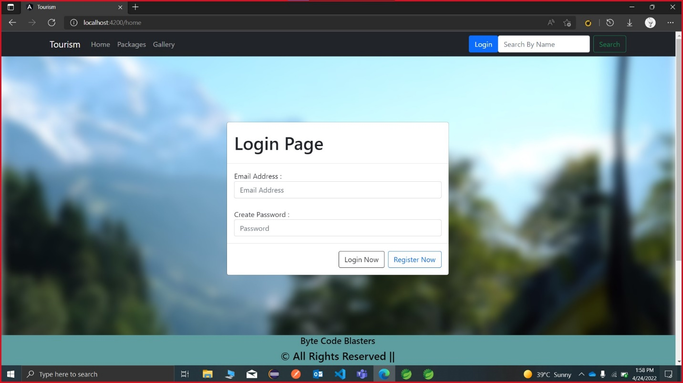

**Registration Page**

This is the second option at the 1st page of our website. As if you are the 1st time visited to our website you will have to enter all the necessary detail as required. Then as you click on the success registration option you will become a registered customer of our website. Now you will be able to login through your personal info to our website and get the perks of our website as a customer.

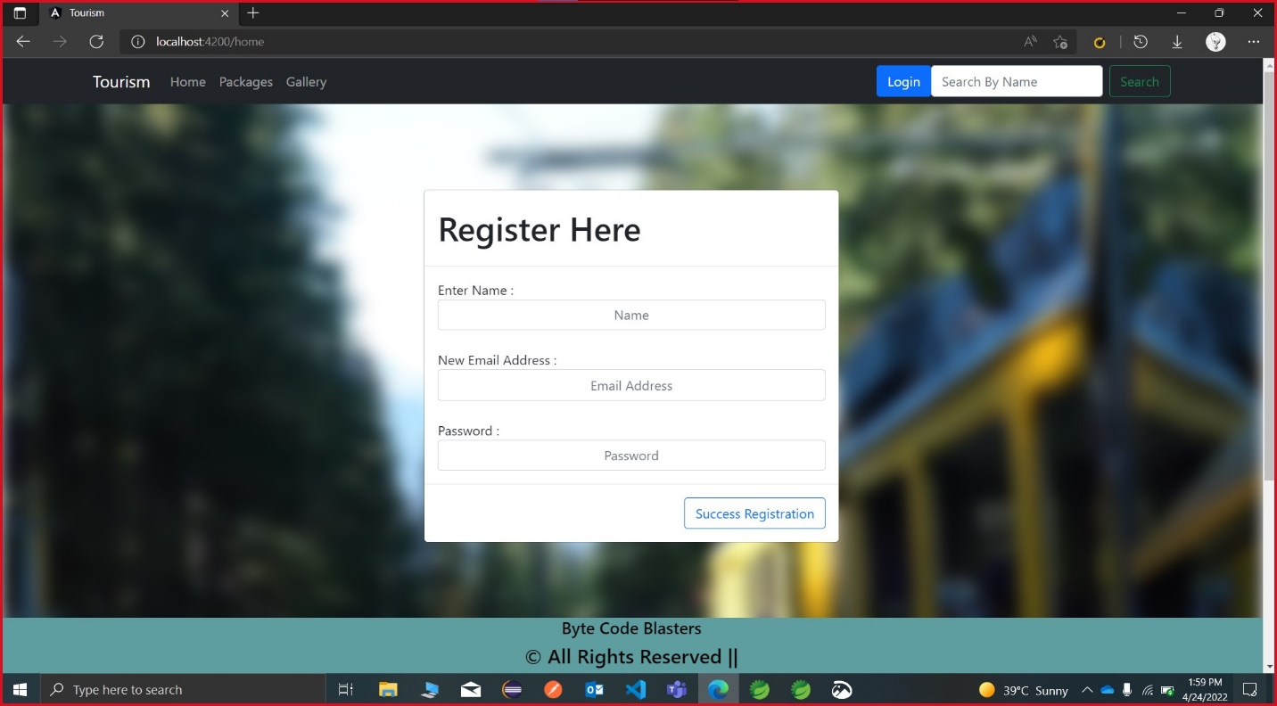

**Admin’s Interface**

**Package Page**

After admin’s log in to our website this is the 1st page which will see. This page mainly shows you the packages already available. It also gives the flexibility to the admin to add new packages. It will also show the delete option so that admin gets the flexibility to delete older packages. It will also show the update option in the package part so that admin will able to update their packages accordingly. It also provides the admin with the add package option so that he can add new packages accordingly.

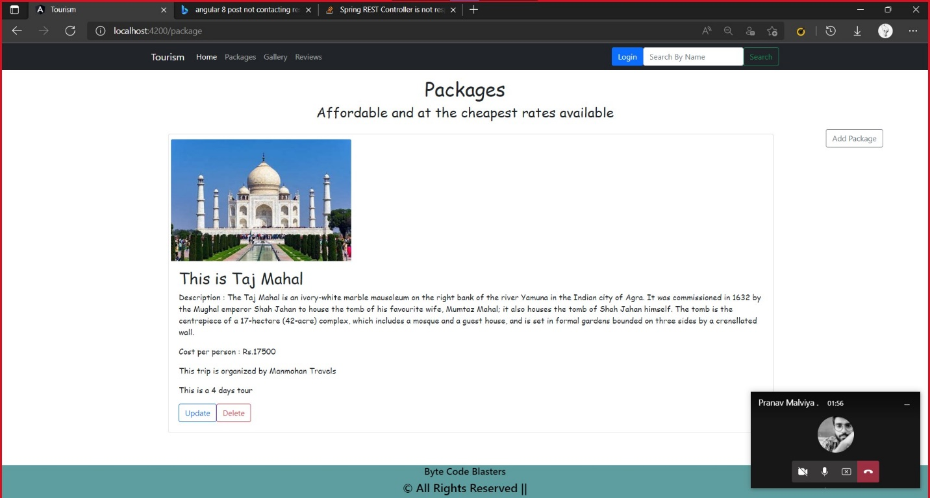

**Update Page**

This is the admin’s update page. It gives the authority to the admin to make some updates in the previous package like you can see the image below he can change the destination points, the description of the destination, cost per person, the local travelling agency that will take users to their respected destination and he can also update some new images of the destination.

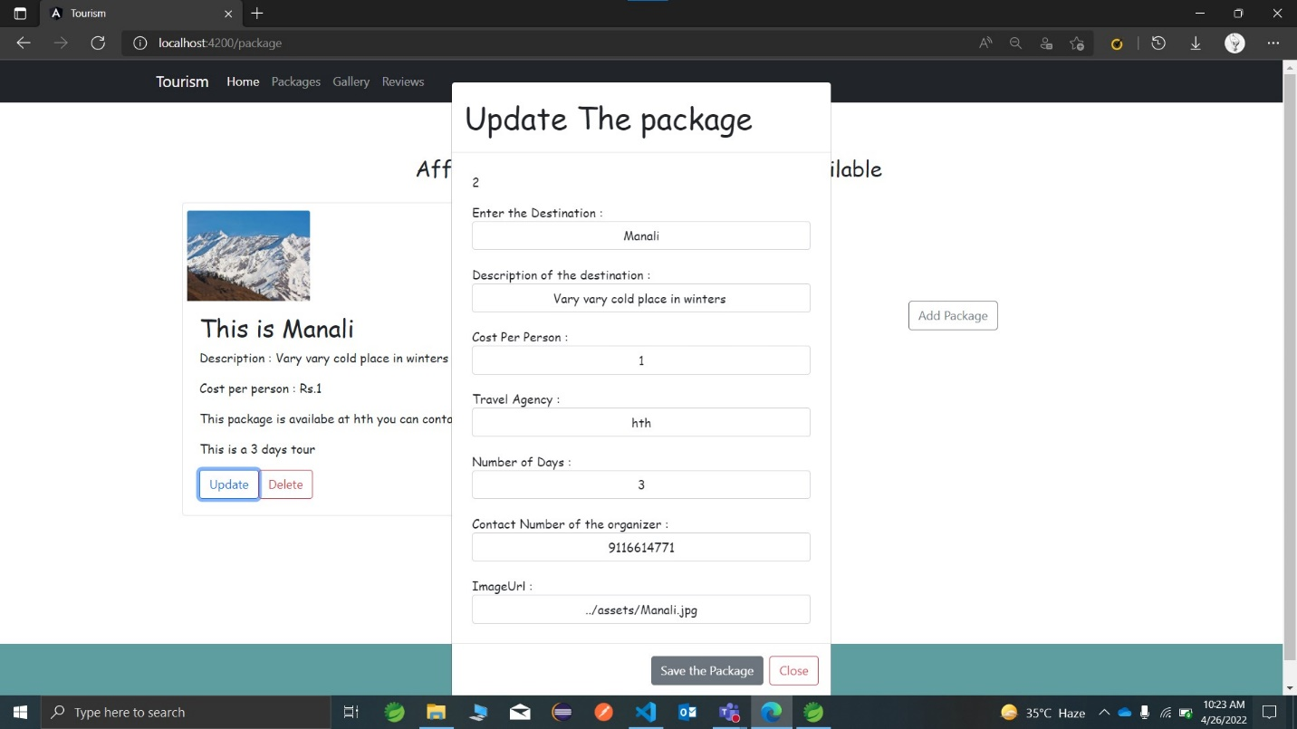

**Delete Page**

This is the delete option which will showed to the admin when he will click on the delete option this will give the admin the authority to delete some useless or older packages available in the website.

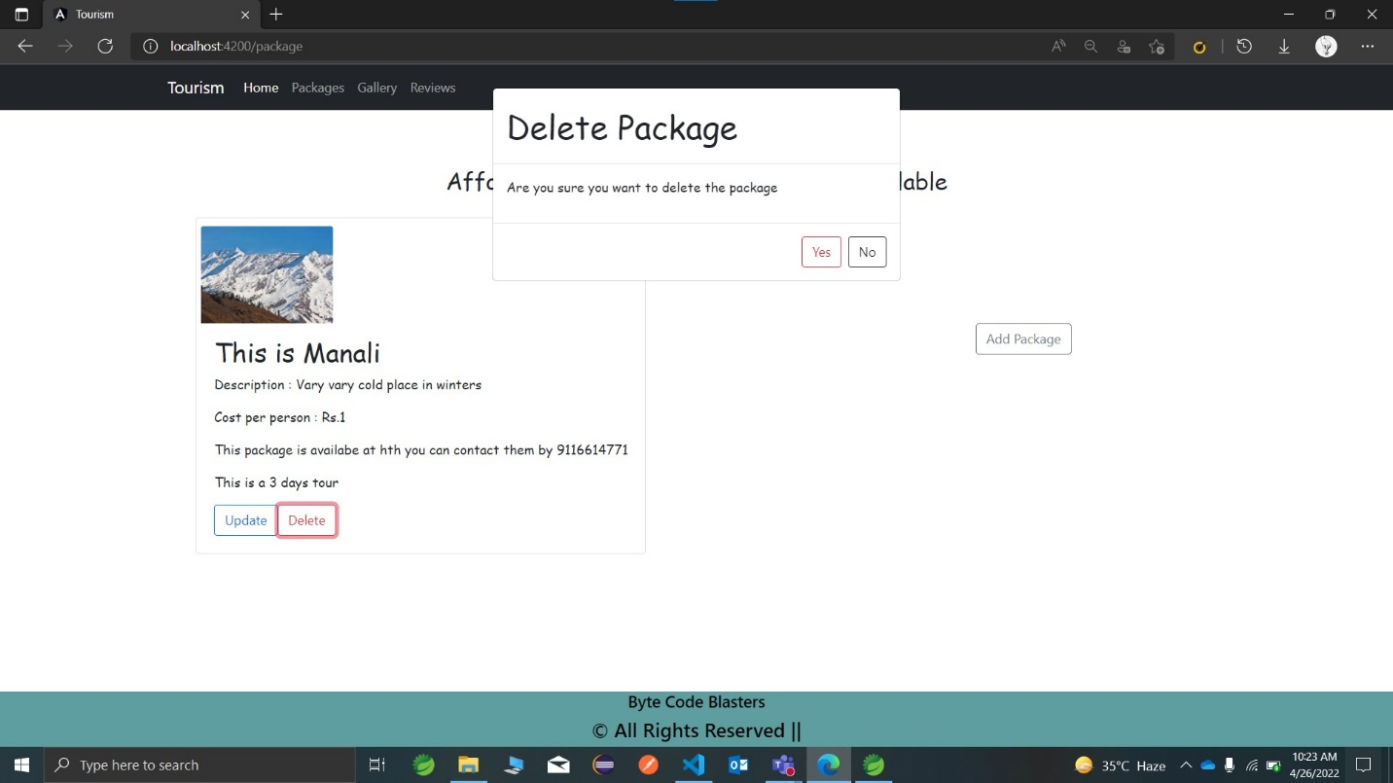

**Add new Package**

This is also the option which will admin get. This will give the flexibility to add some new packages for the users. Here the admin can add the destination point, description of destination, cost per person, the travelling agency that will take them to the destination and he can also add some of the images of the destination so that the user will get the view of your destination and services.

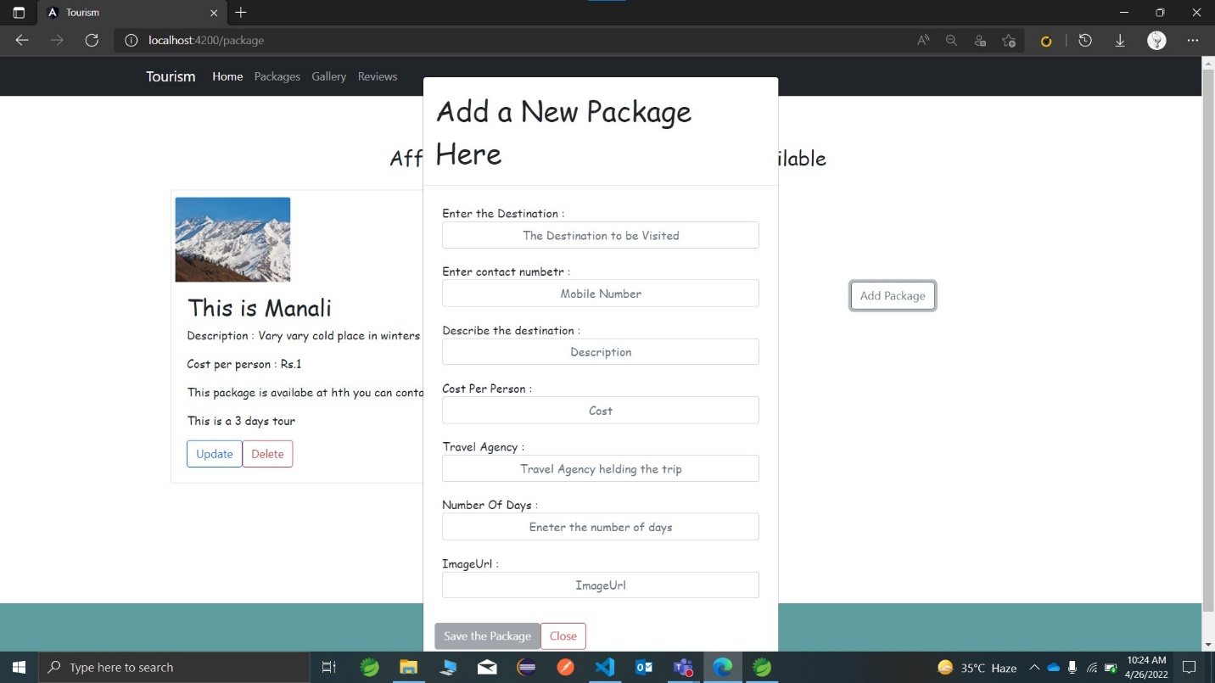

**User’s Interface**

**Package page**

This is the user’s package page this will show the packages to the user so that they can choose their package to travel and they will also have the required information about the package wisely. Here the user can search for the different available packages.

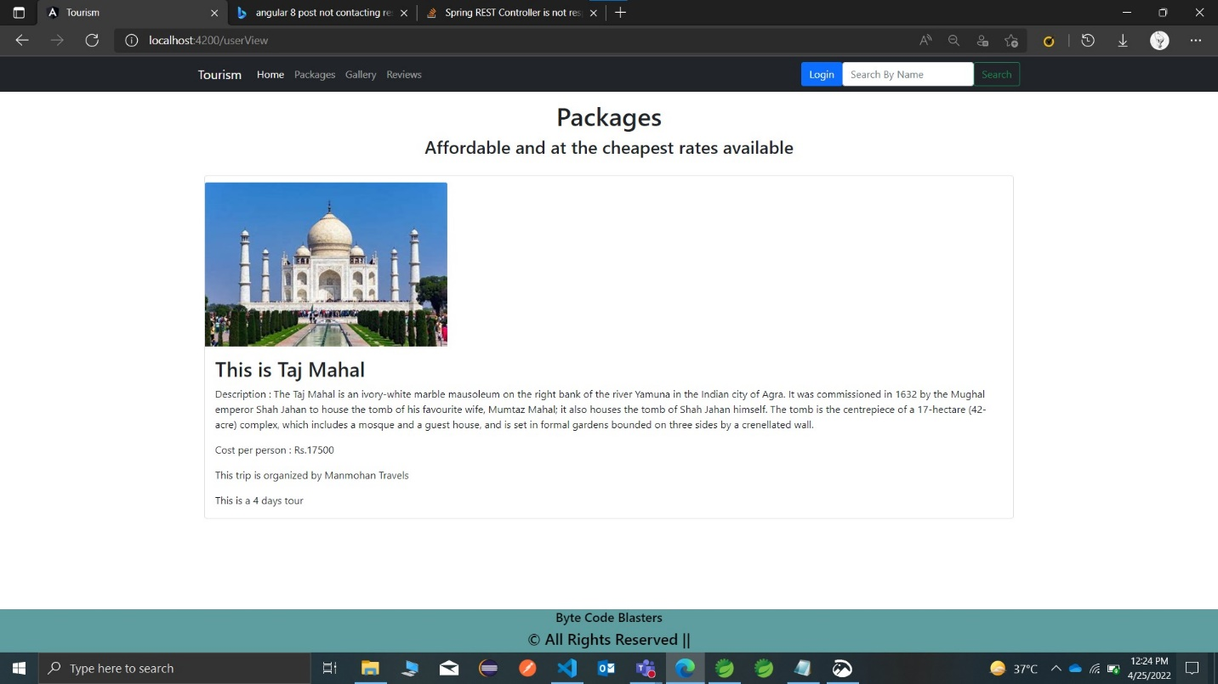

**Review Page**

This is the review page available for the user end so that after the service they can give their reviews and feedback so that we can improvise our site and make it better for the users.

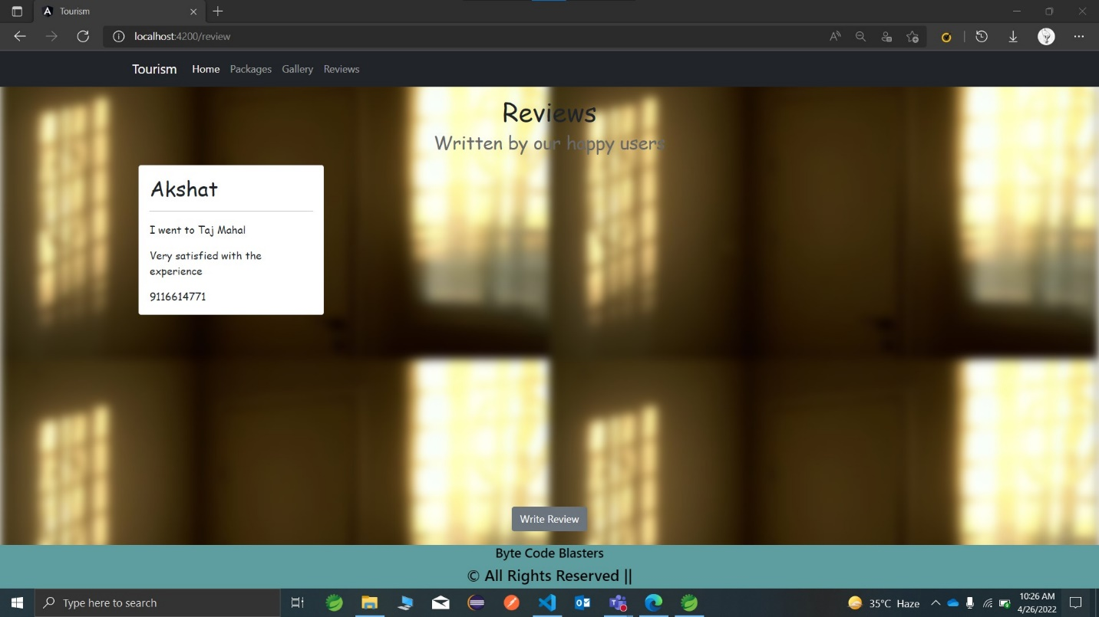

**Gallery**

This is the most beautiful page of our website because this page will connect the user to the real experience that he or she can get from our services and trips.

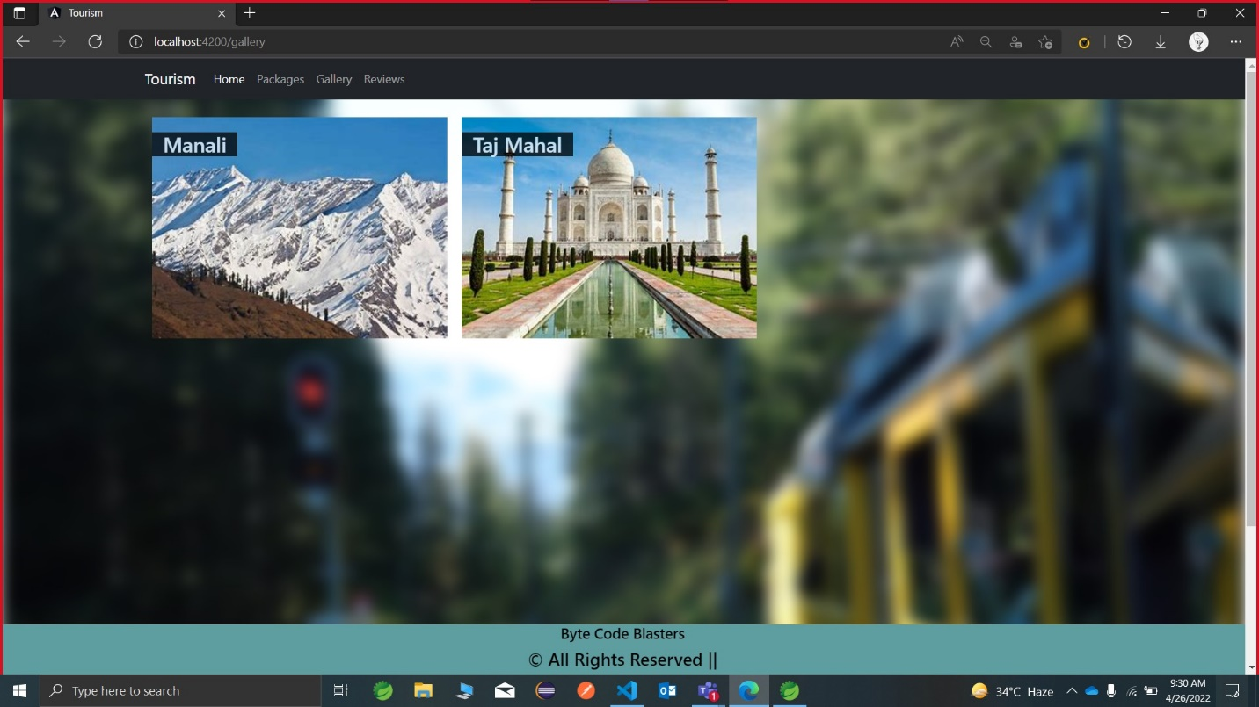

# Scope of Change

Change will not be entertained and whatever specifications mentioned in this document is final. The changes will only happen when a mass community of our users will ask us for the change in our review page.

**Thank you**